GREENPOWER-BRAZEN eBike
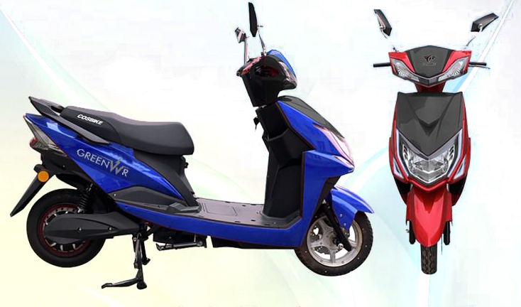

iSPECIFICATIONS:
OVERVIEW BRAZEN
Scooter Dimensions | 1840 x 1150 x 710 mm
Kerb Weight (Kg) | 63 Kg
Mileage (KM/Charge) | 60 km/Charge
Battery and Charger
Battery Type | Advance Lithium Ion Battery Pack
Battery Specification | 60V 24AH @ 0.2C Rating
Charger Output | 60V-5A
Charging Time | 4-5 Hours
Transmission
Motor Type | BLDC HUB Motor mounted in Rear Wheel
Motor Power | <250 Watt
Tyres and Brakes
Tyre Type | Tubeless
Tyre Size (F&R) | 90/90-10
Front and Rear Brake | Disc/Drum
Safety and Features
Odometer | Digital - LCD
Seating Capacity | Driver + Pillion
USB Charging Port | Available
Anti-Theft Alarm | Available
Cruise Control Switch | Available
Chassis and Suspension
Chassis/Frame | Reinforced High Strength Steel
Front Suspension | Telescopic Suspension
Ground Clearance | 115 mm

